VySkan
Product Name | Bluetooth Digital Key & Telematics Terminal
Product Model | VF-Keyless
Access. Connectivity. Security.
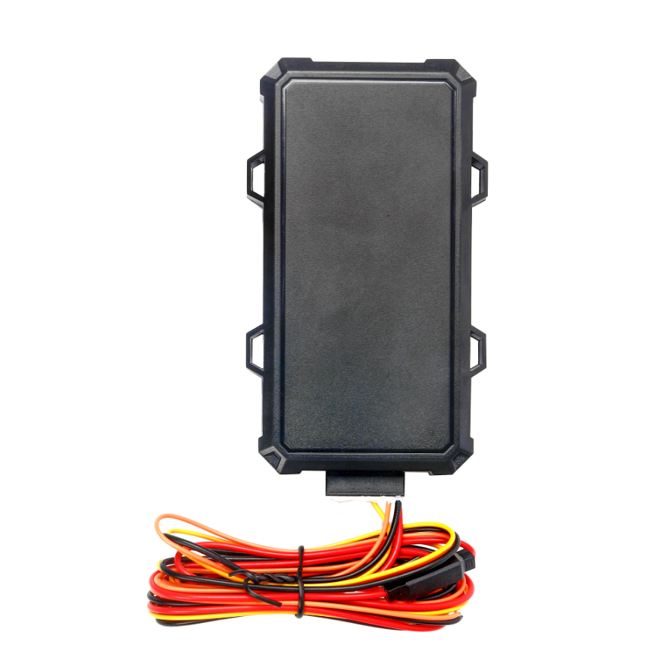
Engineered specifically for car-sharing platforms, vehicle rental businesses, and secure fleet management, the VF-Keyless bridges the gap between traditional GPS tracking and modern keyless access. By integrating secure Bluetooth technology with robust 4G telematics, it allows users to lock, unlock, and manage vehicles directly via a mobile app, completely eliminating the need for physical keys.

Core Value
- Seamless Digital Key Technology
Empowers users to unlock/lock doors, open the trunk, and locate the vehicle using a secure Bluetooth connection via a dedicated app or WeChat Mini Program. Eliminates key handover logistics for rental and sharing fleets.
- Ultra-Wide Voltage & Smart Power
Features an expansive DC 9V-90V operating range compatible with almost any vehicle class. The built-in 3D 3-axis accelerometer detects motion to intelligently switch between active mode and a 5mA ultra-low power sleep mode, protecting the vehicle's battery.
- Active Anti-Theft & Asset Defense
Provides 24/7 security with real-time ACC ignition detection, remote fuel/power cut-off capabilities, and instant alerts for unauthorized power disconnection or low battery voltage.

- Blind-Spot Data Guarantee
Ensures zero data loss. The terminal automatically caches up to 300 telemetry records during cellular blind spots and seamlessly uploads them once the network connection is restored.
- Target Applications
- Car Sharing & P2P Rentals (Keyless entry & remote authorization)
- Enterprise Fleet Management (Digital key allocation & tracking)
- Auto Finance & Leasing (Remote immobilization & asset recovery)
- Logistics & Delivery (Secure cargo access via trunk control)
- Technical Specifications
3.1 Cellular & GNSS
Category | Specification | Description
Network Bands | LTE: B1/B3/B5/B8, B34/B38/B39/B40/B41  (Optional) | Broad coverage for reliable data transmission.
SIM Card | Micro SIM | Internal slot design.
GNSS Chipset | CC1167Q | High-performance tracking module.
Location Modes | BDS / GPS / GLONASS / GALILEO | Multi-constellation support for global accuracy.
Accuracy | ≤ 10 meters | Pinpoint precision for real-time tracking.
Start Time | Cold: Avg 45s  Hot: Avg 3s | Rapid satellite acquisition.
Sensitivity | Tracking: -165dBm  Acquisition: -159dBm | Maintains lock in challenging urban environments.
3.2 Power & Electrical
Category | Specification | Description
Operating Voltage | DC 9V - 90V | Wide voltage range for diverse vehicle compatibility.
Working Current | 30 mA @ 12V | Standard active tracking mode.
Sleep Current | 5 mA @ 12V | Ultra-low power consumption mode.
Backup Battery | 55 mAh | Ensures final alerts during unauthorized power cuts.

3.3 Interfaces & Expandability
Category | Specification | Description
Digital Key Control | Bluetooth App / WeChat Mini Program | Supports lock, unlock, find car, and trunk open commands.
Ignition Detection | 1x ACC Input | Real-time monitoring of vehicle start/stop status.
Immobilization | 1x Oil/Power Cut-off | Remote engine stop capability via external relay.
Power Output | +5V Output | Regulated power supply for small peripherals.
Advanced Controls | Reserved I/O | Hardware supports future window lift and AC control integration.
3.4 Physical & Environmental
Category | Specification | Description
Dimensions | 130mm × 76mm × 22mm | Compact footprint for covert installation.
Operating Temp. | -20℃ to +75℃ | Reliable operation in varied climates.
Storage Temp. | -30℃ to +80℃ | Safe storage in extreme conditions.
Operating Humidity | 5% - 90% RH (Non-condensing) | Resilient in humid environments.
Smart Sensor | 3D 3-axis Accelerometer | Automatically manages sleep/wake cycles based on vibration.

Built for Rapid App & Platform Integration
We know hardware is only half the solution for car-sharing and digital key management. The VF-Keyless is designed to drastically reduce your Time-to-Market (TTM).
- Standard Protocols: Natively supports TCP/IP for seamless backend server communication.
- Bluetooth SDK / API: Comprehensive documentation provided to help your mobile development team effortlessly integrate the lock/unlock and vehicle control features into your own native iOS/Android Apps or WeChat Mini Programs.
- OTA Ready: Supports over-the-air firmware upgrades for effortless fleet maintenance.
- A personalized service prepared for you
- 1× VF-Keyless Sample Device (Pre-configured)
- Full API & Protocol Documentation
- 1-on-1 Technical Support from our Field Engineers
- Contact us
Website：https://vyskan.com/
Email: marketing@vyskan.com

